June 11 Potluck

MPCA
  - Michigan Park Citizens Association
  - www.michiganparkdc.org
Join neighbors for our Spring Potluck hosted by Bob and Lori Moller, 1609 Michigan Avenue NE, Saturday, June 11th, 5-7pm.  The Moller’s house is on the corner of Michigan and South Dakota, behind the bus stop.  The event is a potluck, so bring a dish of your choosing. Great opportunity to meet your neighbors outside of our regular business meetings.  RSVP with an email to michiganpark@gmail.com. Please note your choice of dish – appetizer, salad, main dish or dessert. Drinks and flatware provided.  June 7 Meeting  Last meeting of the school year is Tuesday, June 7, 2016 at 7:15 pm in Ross Auditorium of Providence Hospital. Agenda includes installation of new officers and EYA presentation about development of Saint Josephs Seminary. |  | 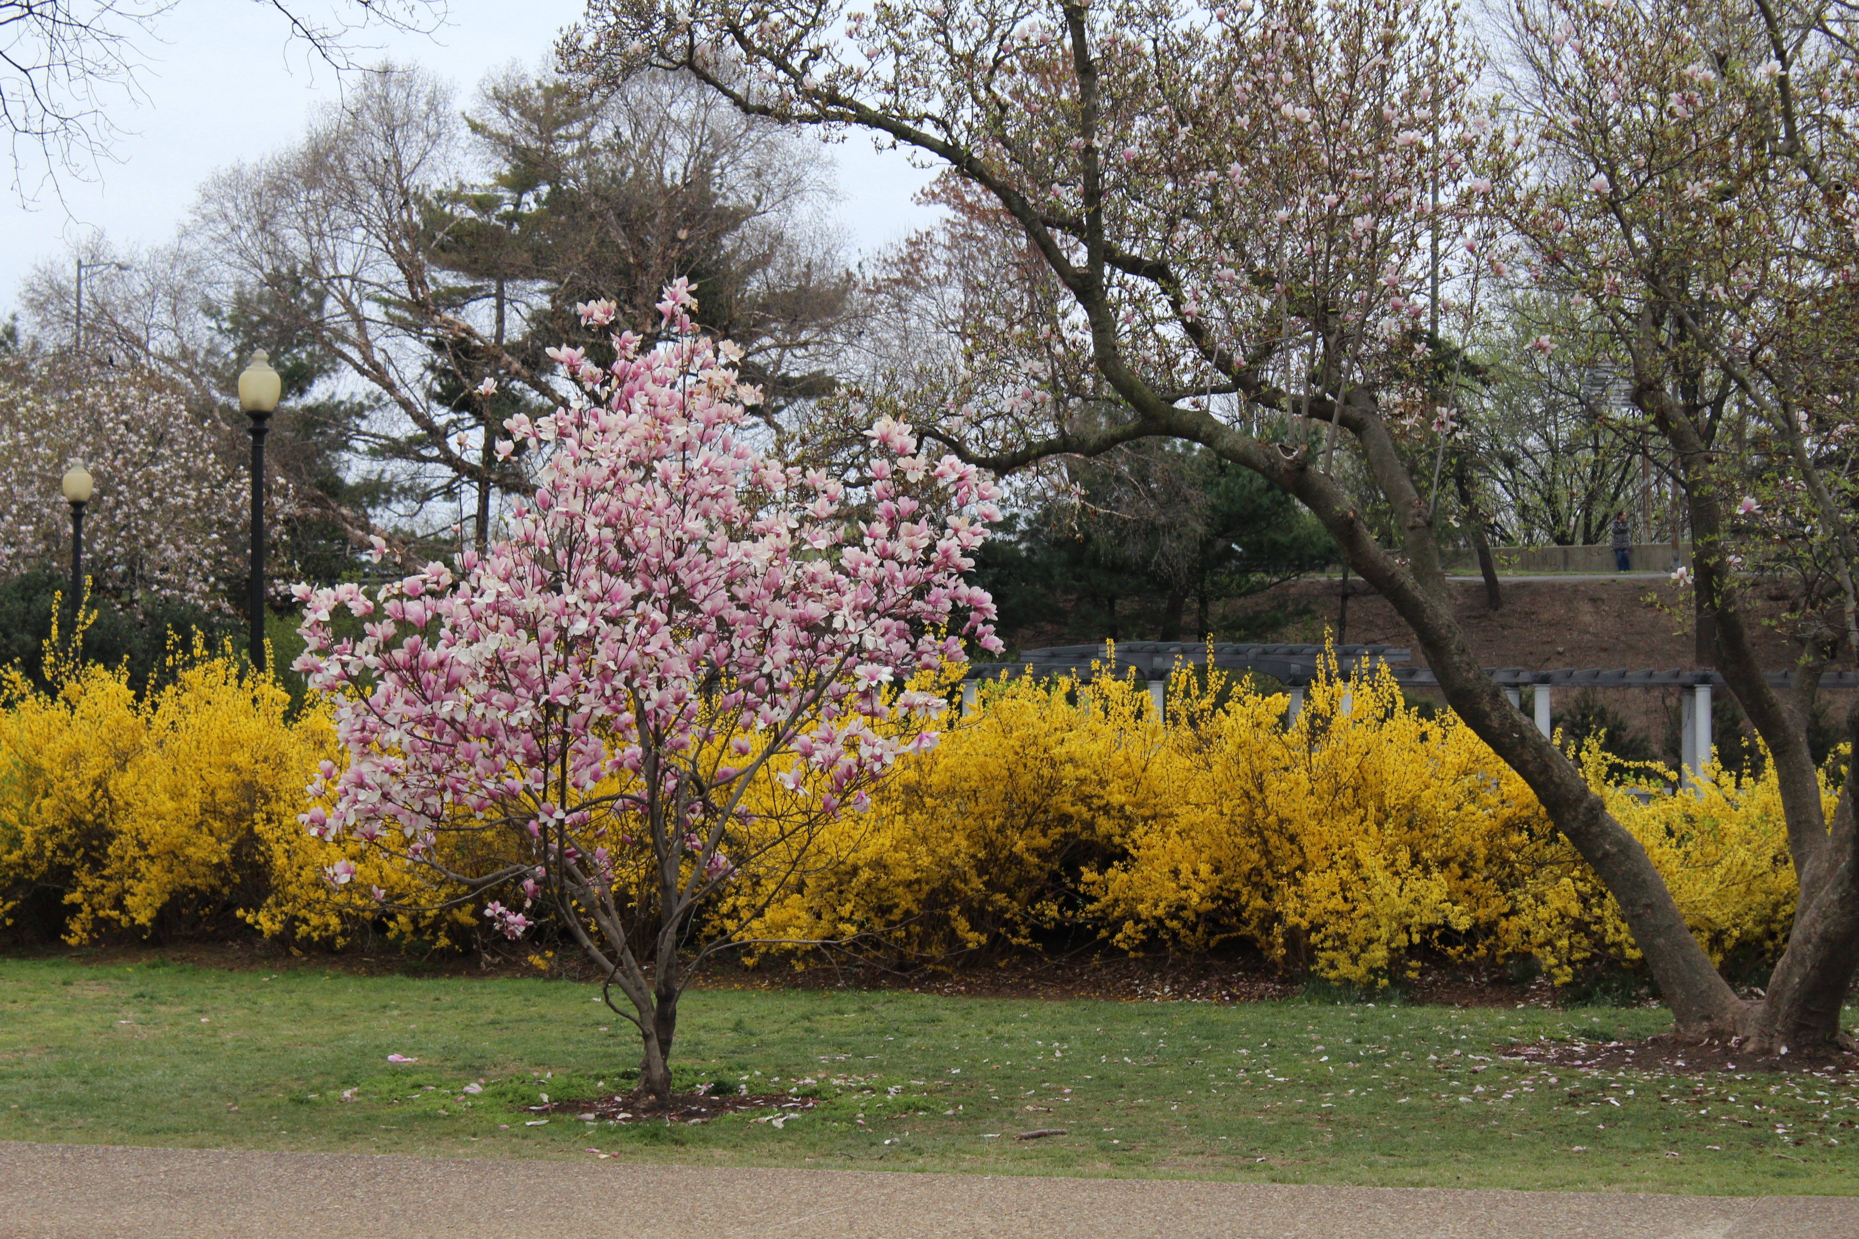  Spring Bloom  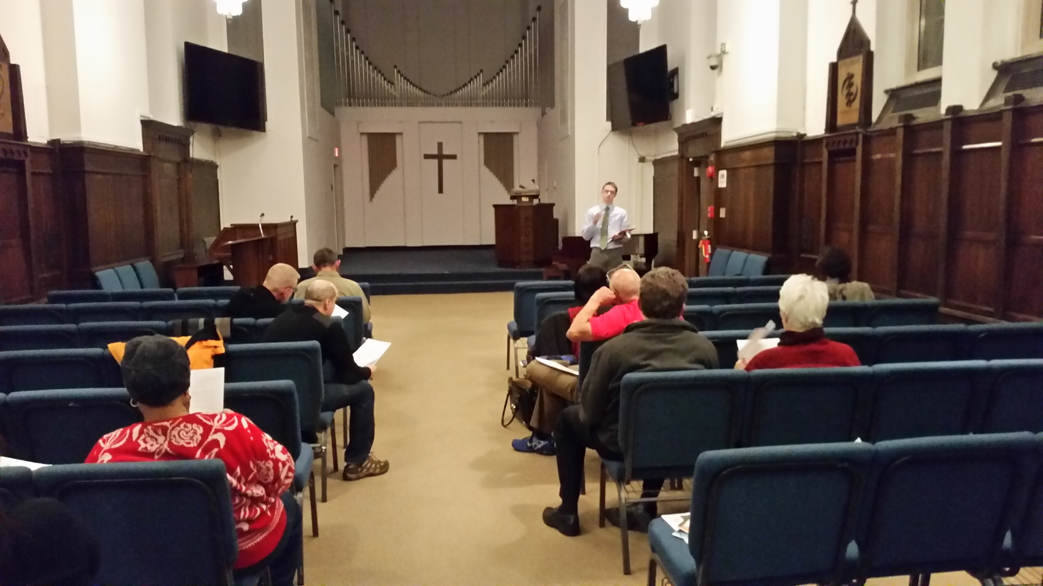  2015 Meeting at Howard Divinity School

Subscribe to our listserv:
https://groups.yahoo.com/neo/groups/MichiganParkDC/Info

